EXPERIMENT 1:
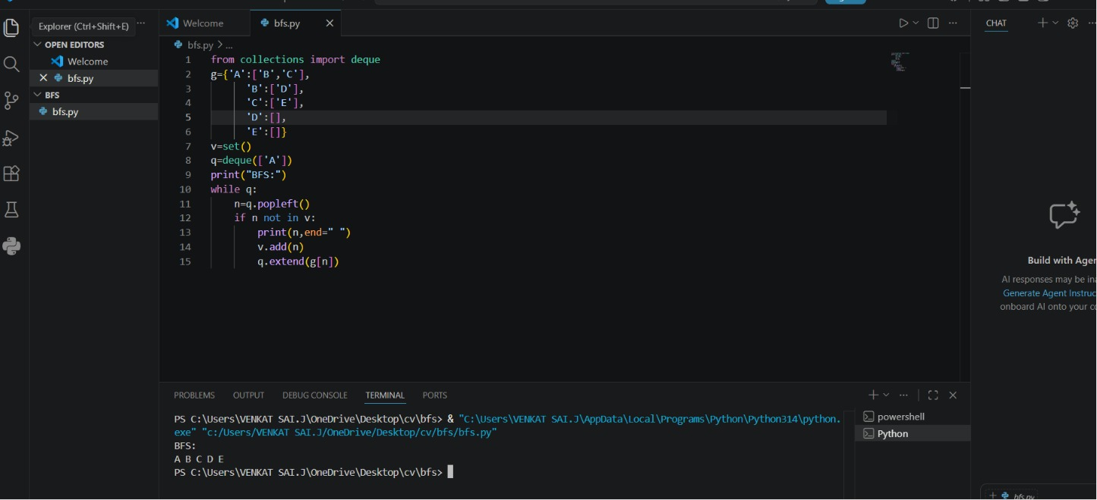
AIM: Breadth First Search

EXPERIMENT 2:
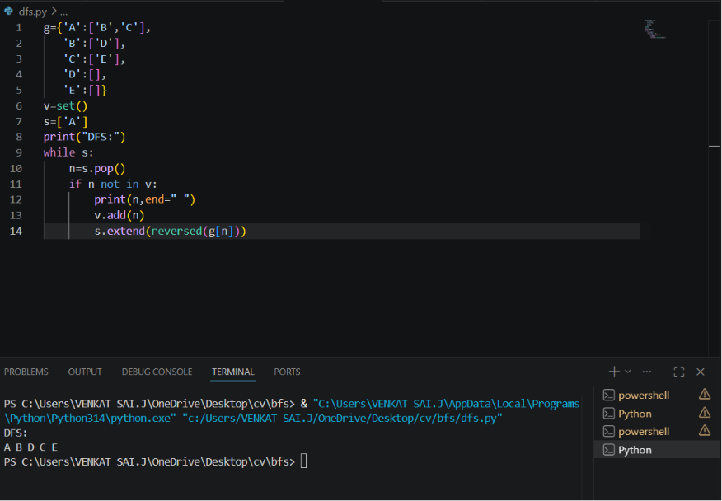
AIM:DEAPTH FIRST SEARCH

EXPERIMENT 3:
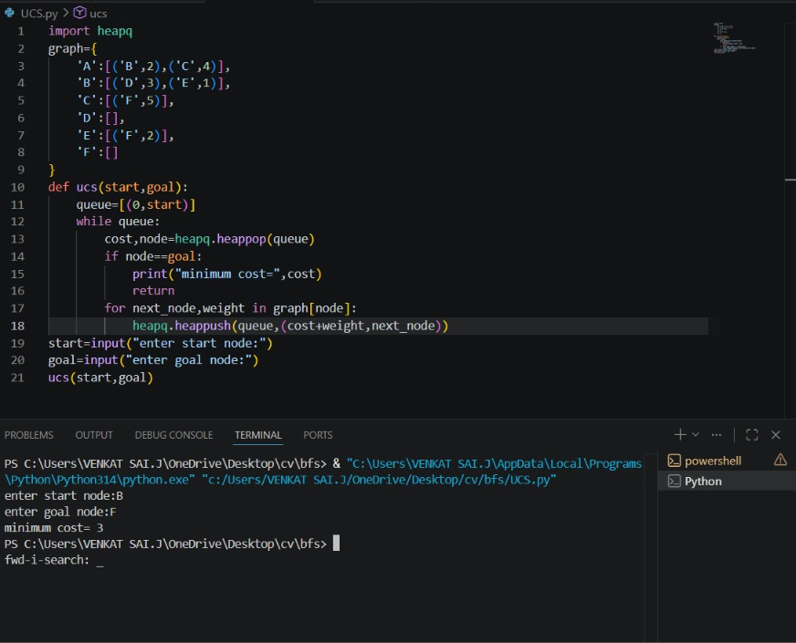
AIM: UNIFORM COST SEARCH

EXPERIMENT 4:
AIM:BEST FIRST SEARCH
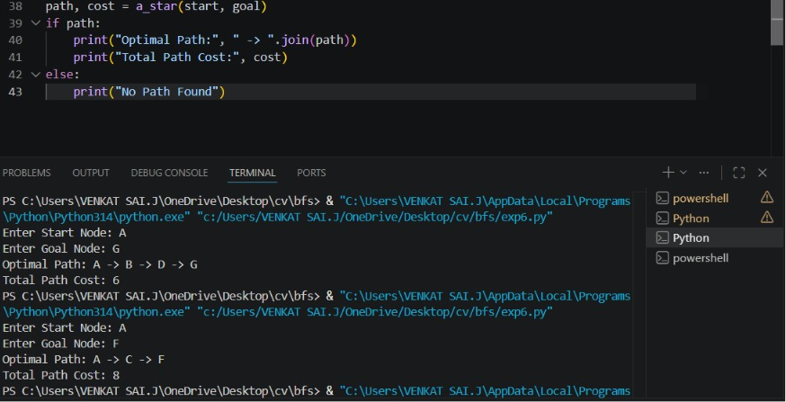
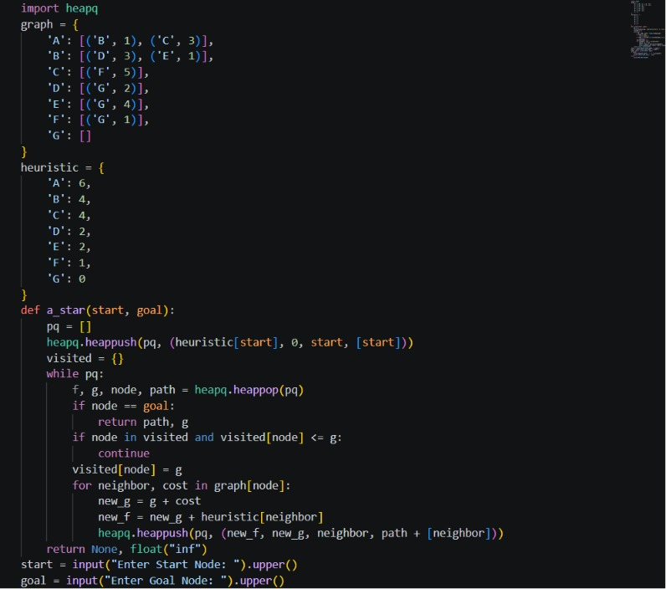
EXPERIMENT 5:
AIM:GRTEEY BREADTH FIRST SEARCH
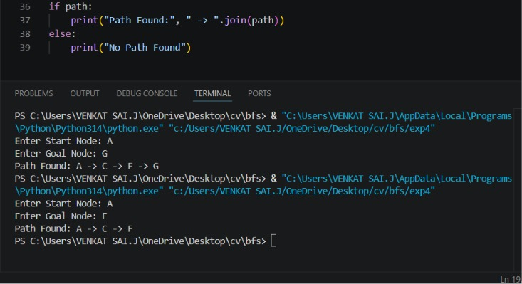
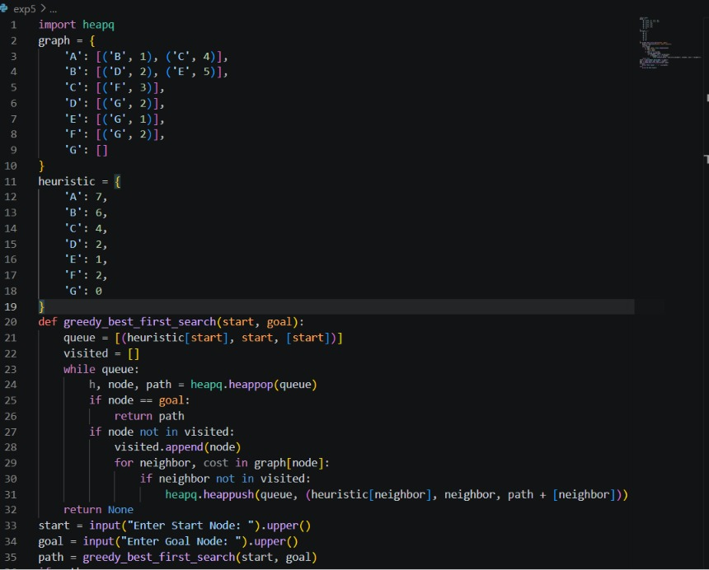
EXPERIMENT 6:
AIM: TWO WATER JUG PROBLEM
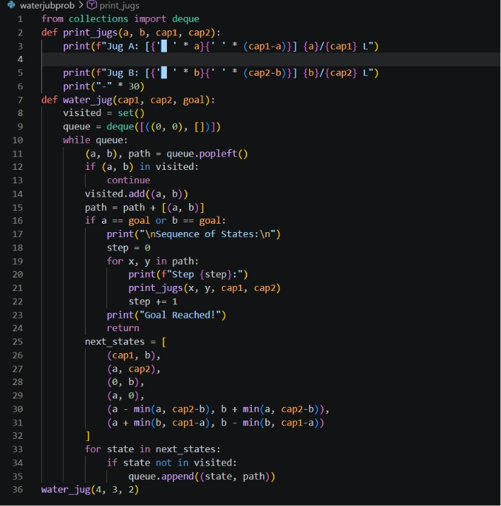
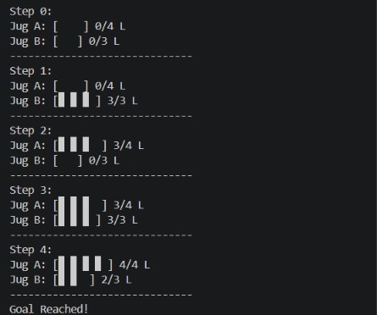
OUTPUT:

